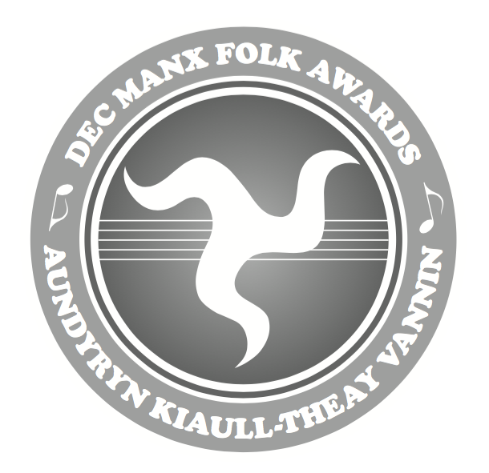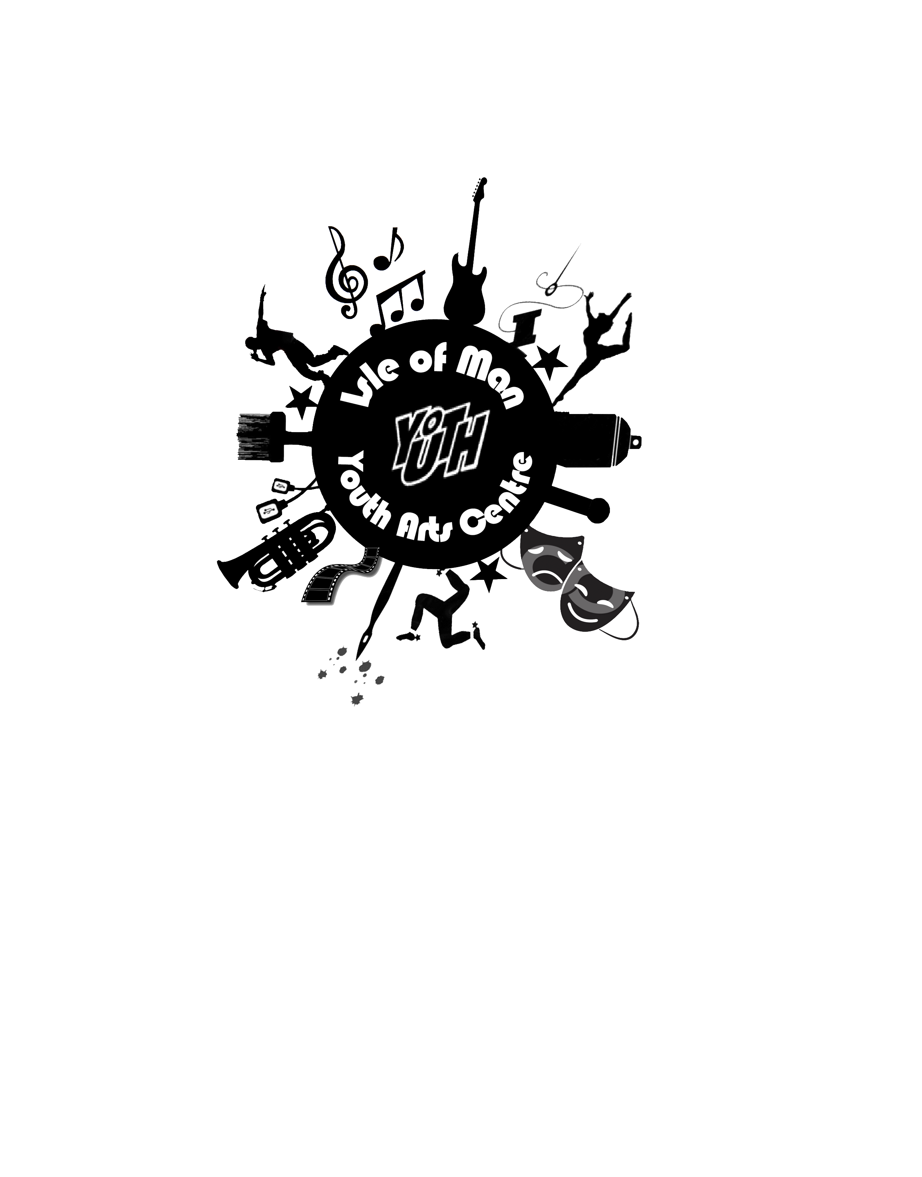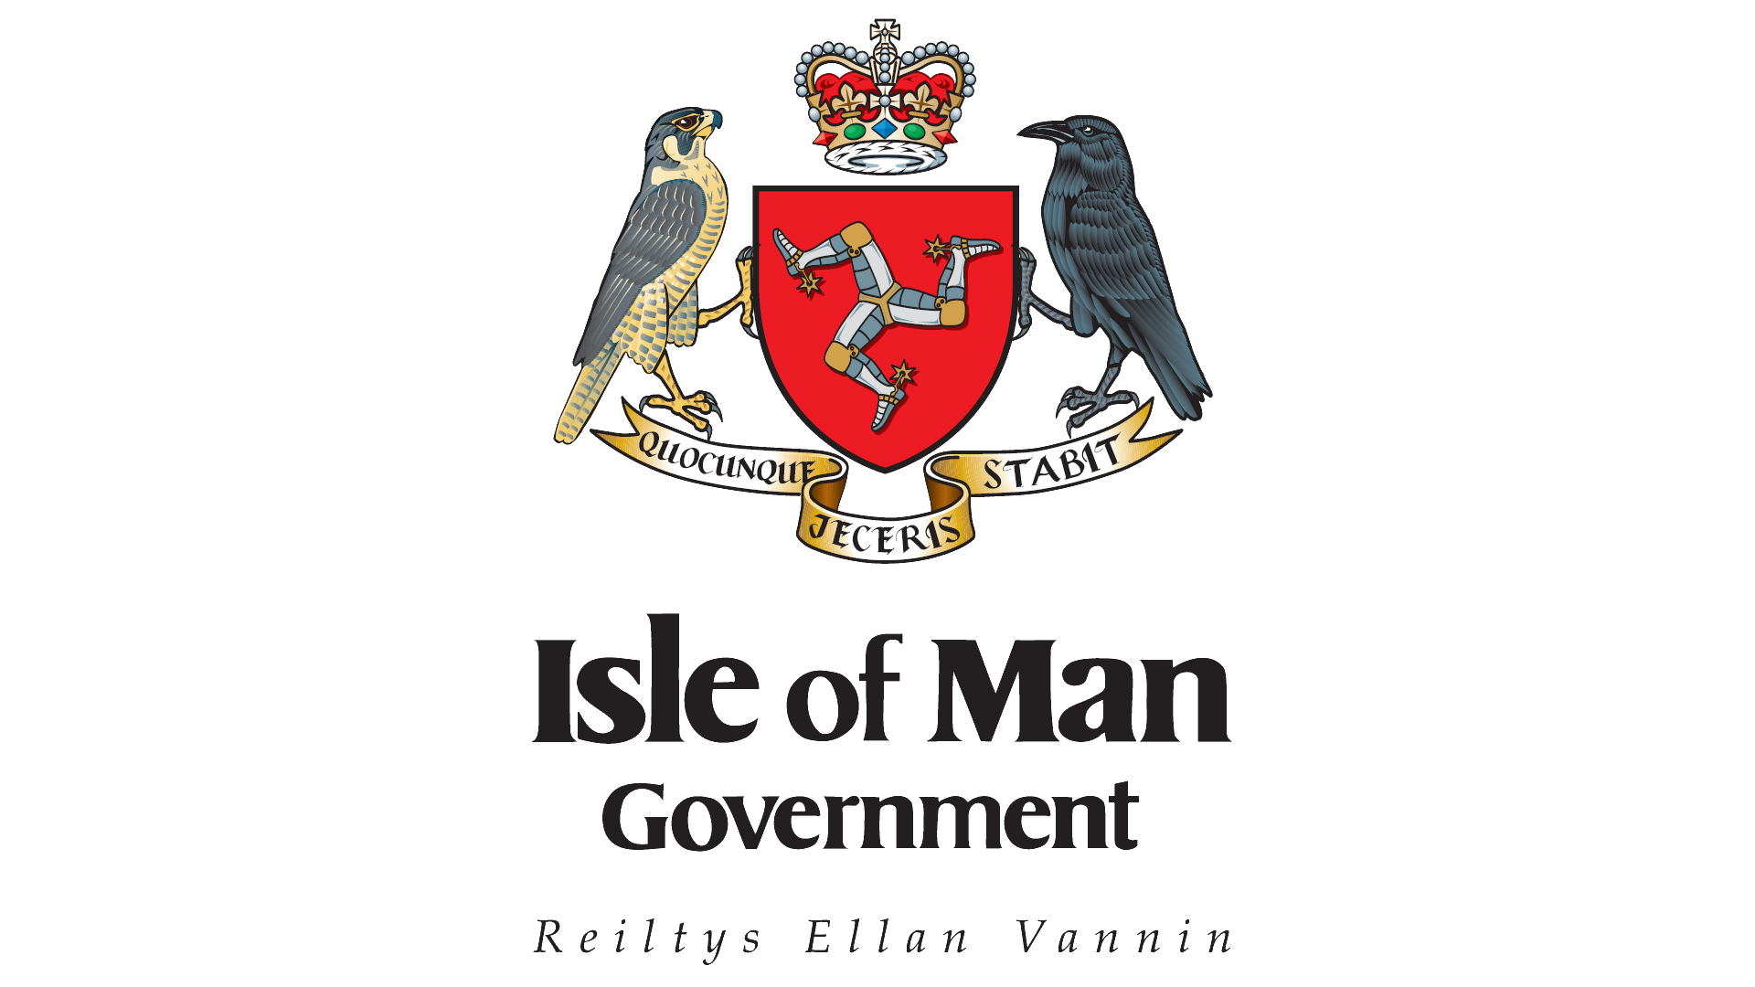

Aundyryn Kiaull-THeay Vannin

April 2nd - 5th 2017

Manx Folk Awards 2017

Secondary

| **The DEC Manx Folk Awards KEY STAGE 3 (only) Classes** | | | | |
| --- | --- | --- | --- | --- |
| **Class No** | **KS 3 Class Name** | **Entrant Names** | **Entrant School / Group Name** | **Notes** |
| 35 | Key Stage 3  Solo instrumental  2 x Manx tunes  *(Max 4 entries per school)* |  |  |  |
|  |  |
|  |  |
|  |  |
| 36 | Key Stage 3  Fiddyl (violin and/or viola)  Solo  2 pieces from the Fiddyl or [Fiddyl Vooar](https://wiki1.sch.im/wiki/pages/g0u4c7/Fiddyl_Vooar.html) books  *(Max 4 entries per school)* |  |  |  |
| 37 | Key Stage 3  Feddan Vooar (flute)  Solo  2 pieces from the Feddan Vooar book  *(Max 4 entries per school)* |  |  |  |
|  |  |
|  |  |
|  |  |
| 38 | Key Stage 3  Prash (brass)  Solo  2 pieces from the [Prash](http://manxfolkawards.weebly.com/instrumental.html) book  *(Max 4 entries per school)* |  |  |  |
|  |  |
|  |  |
|  |  |

2017

|  |  |  |  |  |
| --- | --- | --- | --- | --- |
| 39 | Key Stage 3  Claasagh (harp)  Solo  2 pieces from the [Claasagh](http://livepage.apple.com/) book  *(Max 4 entries per school)* |  |  |  |
|  |  |
|  |  |
|  |  |

| **The DEC Manx Folk Awards KEY STAGE 3 (only) Classes** | | | | |
| --- | --- | --- | --- | --- |
| **Class No** | **KS 3 Class Name** | **Entrant Names** | **Entrant School / Group Name** | **Notes** |
| 40 | Key Stage 3  Solo dance girls/boys  *(Max 4 entries per school)* |  |  |  |
|  |  |
|  |  |
|  |  |
| 41 | Key Stage 3  Recitation (from memory)  “[Fairy Bridge](http://manxfolkawards.weebly.com/recitation.html)” Anon  *(Max 4 entries per school)* |  |  |  |
|  |  |
|  |  |
|  |  |
| 42 | Key Stage 3  Original poetry composition on a Manx theme. Can be in English, Manx dialect or Manx Gaelic.  *(Max 4 entries per school)* |  |  |  |
|  |  |
|  |  |
|  |  |

|  |  |  |  |  |
| --- | --- | --- | --- | --- |
| 43 | Key Stage 3  Solo song in Manx Gaelic  *(Max 4 entries per school)* |  |  |  |
|  |  |
|  |  |
|  |  |
| 44 | Key Stage 3  Solo song in English on a Manx theme  *(Max 4 entries per school)* |  |  |  |
|  |  |
|  |  |
|  |  |

| **The DEC Manx Folk Awards KEY STAGE 4 & 5 (only) Classes** | | | | |
| --- | --- | --- | --- | --- |
| **Class No** | **KS 4 & 5 Class Name** | **Entrant Names** | **Entrant school / group names** | **Notes** |
| 45 | Key Stage 4 & 5  Solo instrumental  2 x Manx tunes  *(Max 4 entries per school)* |  |  |  |
|  |  |
|  |  |
|  |  |
| 46 | Key Stage 4 & 5  Solo song in Manx Gaelic  *(Max 4 entries per school)* |  |  |  |
|  |  |
|  |  |
|  |  |
| 47 | Key Stage 4 & 5  Solo song in English on a Manx theme  *(Max 4 entries per school)* |  |  |  |
|  |  |
|  |  |
|  |  |

2017

|  |  |  |  |  |
| --- | --- | --- | --- | --- |
| 48 | Key Stage 4 & 5  Recitation (from memory)  “[Fairy Bridge](http://manxfolkawards.weebly.com/recitation.html)” Anon  *(Max 4 entries per school)* |  |  |  |
|  |  |
|  |  |
|  |  |

|  |  |  |  |  |
| --- | --- | --- | --- | --- |
| 49 | Key Stage 4 & 5  Original poetry composition on a Manx theme. Can be in English, Manx dialect or Manx Gaelic.  *(Max 4 entries per school)* |  |  |  |
|  |  |
|  |  |
|  |  |
| 50 | Key Stage 4 & 5  Solo Dance girls / boys  *(Max 4 entries per school)* |  |  |  |
|  |  |
|  |  |
|  |  |

| **The DEC Manx Folk Awards KEY STAGE 4 & 5 (only) Classes** | | | | |
| --- | --- | --- | --- | --- |
| **Class No** | **KS 4 & 5 Class Name** | **Entrant Names** | **Entrant school / group names** | **Notes** |

| **The DEC Manx Folk Awards KEY STAGE 3 4 & 5 (any combination) Classes** | | | | |
| --- | --- | --- | --- | --- |
| **Class No** | **KS 3 4 & 5 Class Name** | **Entrant Names** | **Entrant School / Group Name** | **Notes** |
| 51  NEW | Key Stage 3 4 & 5  Choir/group singing (3 - 30 students)  “[S’Feayr yn Oie](http://manxfolkawards.weebly.com/set-pieces-2017.html)” (Coraa)  (2 songs) *(5 mins maximum)* |  |  | Total Number of singers: |
| 52 | Key Stage 3 4 & 5  Balanced programme of Manx dances  Solo & team dances can be included as well as original compositions  *(not exceeding 10 minutes)* |  |  | Total Number of Dancers: |
| 53 | Key Stage 3 4 & 5  Duet /Trio instrumental  2 x Manx tunes  *(Max 4 entries per school)* |  |  |  |
|  |  |
|  |  |
|  |  |
| 54 | Key Stage 3 4 & 5  Group instrumental  Minimum 2 Manx tunes (max 5 minutes)  *(any style or interpretation but adult accompanist mustn’t play tune)* |  |  | Total Number of Instrumentalists: |

2017

| **The DEC Manx Folk Awards KEY STAGE 3 4 & 5 (any combination) Classes** | | | | |
| --- | --- | --- | --- | --- |
| **Class No** | **KS 3 4 & 5 Class Name** | **Entrant Names** | **Entrant School / Group Name** | **Notes** |
| 55 | Key Stage 3 4 & 5  Manx couples dance  *(Max 4 entries per school)* |  |  |  |
|  |  |
|  |  |
|  |  |
| 56 | Key Stage 3 4 & 5  Original composition in a Manx idiom  *(played or sung)* |  |  |  |

|  |  |  |  |  |
| --- | --- | --- | --- | --- |
| 57 | Key Stage 3, 4 & 5  **Manx Gaelic Reading**  **All Learners**  “Yn Lion as yn Lugh"  [Link Here](http://manxfolkawards.weebly.com/manx-readings-2017.html)  *(maximum 4 entries per school)* |  |  |  |
|  |  |
|  |  |
|  |  |

|  |
| --- |
| CLOSING DATE FOR COMPETITION ENTRIES: **February 17th 2017**   * **Secondary competitions will be held on the afternoon of Sunday 2nd April at Douglas Youth Arts Centre at 1pm** * Where a maximum of 4 students is permitted per competition, schools may request a qualifying competition in advance of the Manx Folk Awards. We can offer assistance in the form of an adjudicator at a date to suit. Please contact [mfa@online.sch.im](mailto:mfa@online.sch.im) Except where stated, all classes can be accompanied or unaccompanied. Adults should refrain from playing the tune. * Secondary **solo** competitions have been split into Key Stage 3 and Key Stage 4 and 5. The secondary **group** competitions (including duets) remain a mix of Keystage 3, 4 and 5. * Due to fire regulations we have had to place a maximum number on the group classes. Where asked, please state the total number of children in that class on the entry form so we know final numbers. * If you require live music in the dance competitions this can be provided, please contact [mfa@online.sch.im](mailto:mfa@online.sch.im) * There may be media present. Please can you write below the names of any children who are not to be photographed or videoed. This will be passed to the media so they can cross check. Please tick the box if all children from your school are fine to be photographed so we can be clear you have read this statement:   Please email entries to: [mfa@online.sch.im](mailto:mfa@online.sch.im) or post to:  **Jo Callister**  **Advisory Teacher for the Manx Curriculum**  **Hamilton House**  **Peel Road**  **Douglas**  **IM1 5EZ**  Resources and support for these competitions can be found on the DEC Manx Folk Awards website: |

|  |  |  |  |
| --- | --- | --- | --- |
| **Names of children NOT to be photographed or videoed (school name) ____________________________** | | | |
|  |  |  |  |
|  |  |  |  |
|  |  |  |  |

Please tick the box if all children taking part in the Folk Awards from (school/group):

________________________________________________________

are able to be photographed and appear in the media.

<http://manxfolkawards.weebly.com/>